Holiday Open House 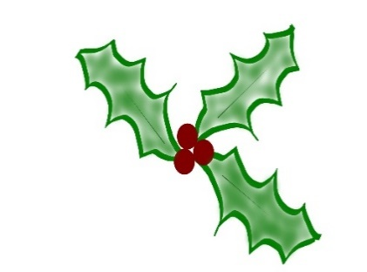
Second Floor, Town Office Building
Friday, December 8th from 9-11:30
Please join us for holiday cheer and a refreshments

