Annual Town Rabies Clinic
Hosted by
East Bridgewater Board of Health and
Mobile Animal Care

Monday, June 10, 2024,
5:00 P.M. – 7:00 P.M.

Sachem Rock Farm
335 Plymouth Street, East Bridgewater
Rain date is scheduled for Tuesday, June 11th, 2024.
5:00 P.M. – 6:00 P.M. CATS ONLY
6:00 P.M. – 7:00 P.M. DOGS
Cost of vaccination is $10 per pet. Cash only.
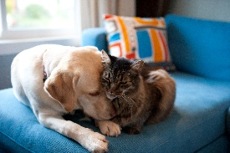
All Cats MUST be in carriers, and all dogs MUST be leashed.

Please bring proof of previous rabies vaccination.
Town Clerk staff will be on site for East Bridgewater residents to license their dogs.
We will also be collecting donations of new pet items to be given to a local shelter. Acceptable items include pet food, treats, cat litter, litter pans, toys, leashes, food bowls, and cleaning supplies.

